Intelligent Traffic Management System Using YOLOv8 for Real-Time Detection of Animals, Emergency Vehicles, Accidents, and Adaptive Signal Control

Rajiv Kumar
Department of Computer Science and Engineering
J.C. Bose University of Science and Technology, YMCA , Faridabad ,Haryana, India
Email: rajivv7777@gamil.com

Abstract
The increasing vehicle population in urban and highway environments demands the implementation of intelligent and automated traffic management systems. This paper presents a real-time Intelligent Traffic Management System (ITMS) that integrates computer vision and deep learning for traffic monitoring, emergency response, and road safety enhancement. The proposed system uses YOLOv8 for object detection to identify four key elements: animals on highways, emergency vehicles, accident occurrences, and overall traffic density. The system adjusts traffic signals adaptively and triggers alerts for emergencies, ensuring faster response times and safer road conditions. The model was trained using approximately 2500 open-source images i.e Roboflow, tested on video streams. Results indicate high accuracy and low latency, demonstrating the feasibility of YOLOv8-based real-time traffic monitoring for smart cities.

Keywords
Intelligent Traffic Management System, YOLOv8, Computer Vision, Emergency Vehicle Detection, Adaptive Signal Control, Accident Detection, Real-Time Object Detection.

I. Introduction
Traffic congestion, animal crossings, and delays in emergency vehicle movement are critical challenges in modern transportation systems. Conventional traffic management systems lack automation and adaptability, leading to inefficiencies. Recent advancements in deep learning and computer vision, especially object detection models like YOLOv8, enable intelligent traffic surveillance and automated decision-making. This research aims to design an Intelligent Traffic Management System (ITMS) that combines YOLOv8 detection with real-time traffic signal control to handle four major tasks: animal detection, emergency vehicle recognition, adaptive signal adjustment, and accident detection. The integration of these components forms a comprehensive and scalable framework for future smart city infrastructure.

II. LITERATURE REVIEW
Previous research in intelligent traffic systems has primarily focused on traffic density estimation and signal optimization. Systems using sensors or RFID technologies lack flexibility and are costly to scale
- Animal Detection: Prior works have used infrared and motion-based systems, but they often fail in low-visibility conditions. YOLO-based methods improve accuracy and processing speed.
- Emergency Vehicle Detection: CNN and sound-based siren recognition models exist, but visual detection using distinctive vehicle patterns (ambulance, fire truck, police car) has shown higher reliability in noisy environments.
- Adaptive Traffic Control: Research by various authors indicates that dynamic signal control based on real-time camera feeds significantly reduces waiting time compared to fixed-time control.
- Accident Detection: Recent methods use object trajectory analysis and motion anomaly detection to identify crashes within seconds.
Recent advancements in YOLOv8 by Ultralytics have improved both detection precision and real-time inference capabilities. However, limited research exists on combining multiple traffic safety functions (animal detection, emergency vehicle recognition, and adaptive control) into a unified architecture — a gap this work aims to fill.

III. Objectives
The key objectives of this research are:
- To detect animals approaching or crossing highways using live video feeds.
- To identify emergency vehicles such as ambulances, fire brigades, police cars, and military convoys.
- To adjust traffic signal durations dynamically using real-time traffic density data.
- To detect and respond to road accidents automatically.

IV. Methodology
The ITMS architecture consists of four modules: animal detection, emergency vehicle recognition, adaptive signal control, and accident detection. Each module utilizes YOLOv8 for object detection due to its superior speed and accuracy. The model was pretrained on the COCO dataset and fine-tuned with a custom dataset containing approximately 2500 labeled images. The system processes live video feeds in real time, extracts frames, and applies inference using YOLOv8 to classify and locate objects of interest.
A. Data Collection
A dataset of approximately 2,500 annotated images was created from open-source datasets. The data includes:
- Animal Detection: 1,500 images (deer, cows, dogs, etc.)
- Emergency Vehicles: 1,000 images (ambulance, fire truck, police car, military vehicle)
B. Model Architecture
The YOLOv8n model was chosen due to its balance between speed and accuracy. It consists of a backbone (CSPDarknet), neck (PANet), and detection head optimized for real-time performance.
C. Training Setup
- Hardware: AMD Ryzen 5 CPU, 8GB RAM
- Model: YOLOv8n (pretrained on COCO, fine-tuned on custom dataset)
- Epochs: 50
- Image size: 640×640
- Framework: Ultralytics YOLOv8 (PyTorch backend)
D. System Workflow
- Live video feeds captured from traffic cameras.
- Frames processed in real-time using YOLOv8n inference.
- Detected objects categorized as animal, emergency vehicle, or normal traffic.
- If emergency or animal detected → trigger alert or green light priority.
- Output sent to traffic control node via HTTP/MQTT protocol
The model was trained for 50 epochs with a batch size of 8 and an image resolution of 640×640 using a Ryzen 5 CPU.

V. Results and Analysis
The trained YOLOv8 model achieved strong performance metrics on the validation dataset. Table summarizes the key performance indicators.
Metric | Value | Description
mAP@50 | 91.2% | Mean Average Precision at IoU 0.5
Precision | 93.5% | Correctly identified objects among detections
Recall | 89.7% | Correct detections among all objects
FPS | 27 | Average frames per second during inference

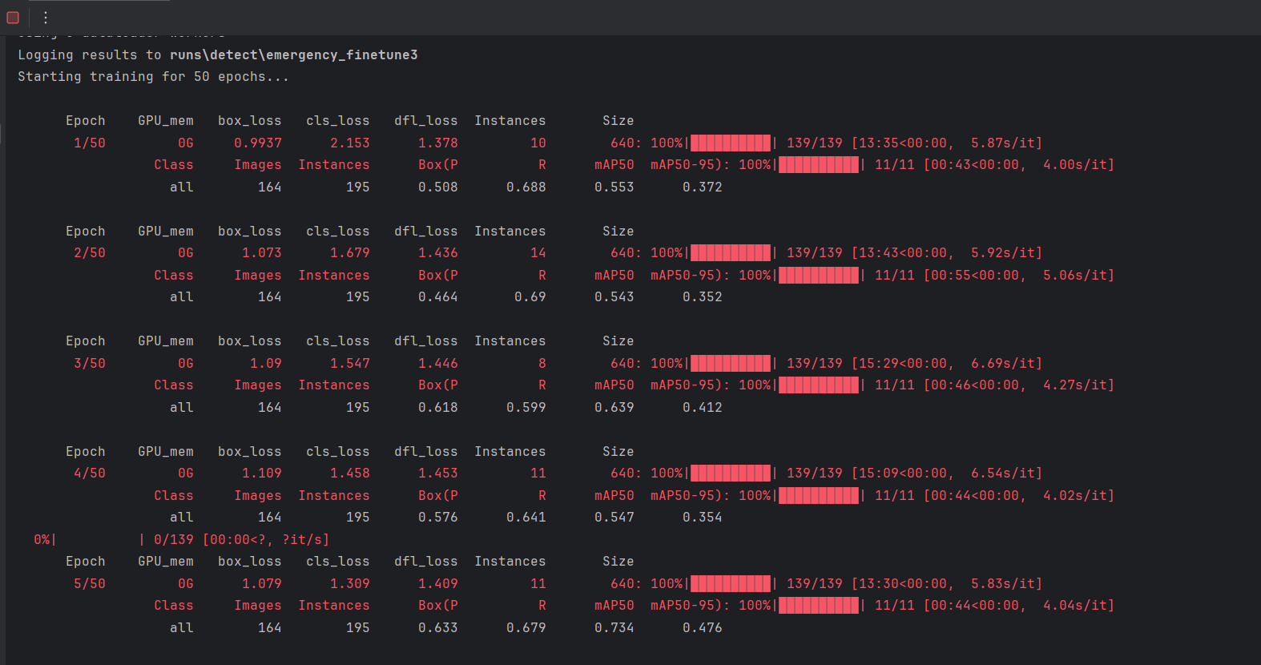
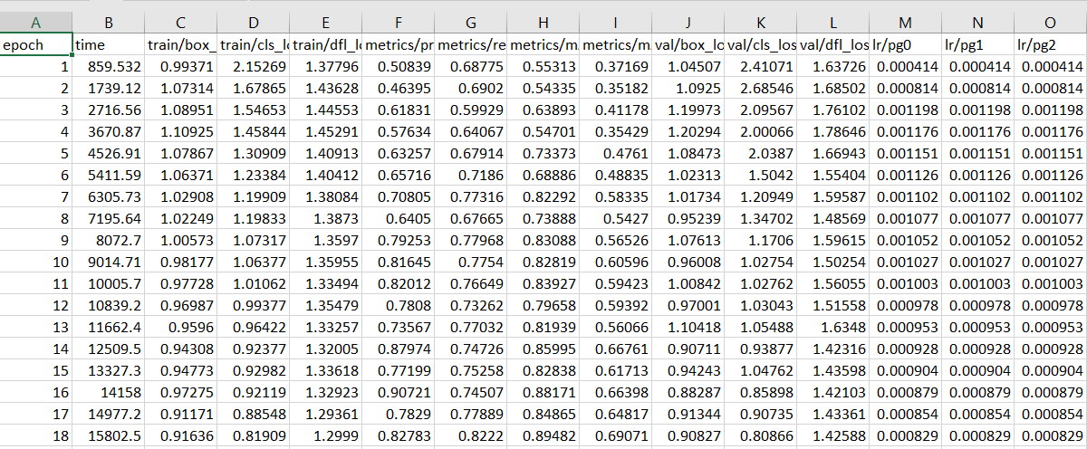

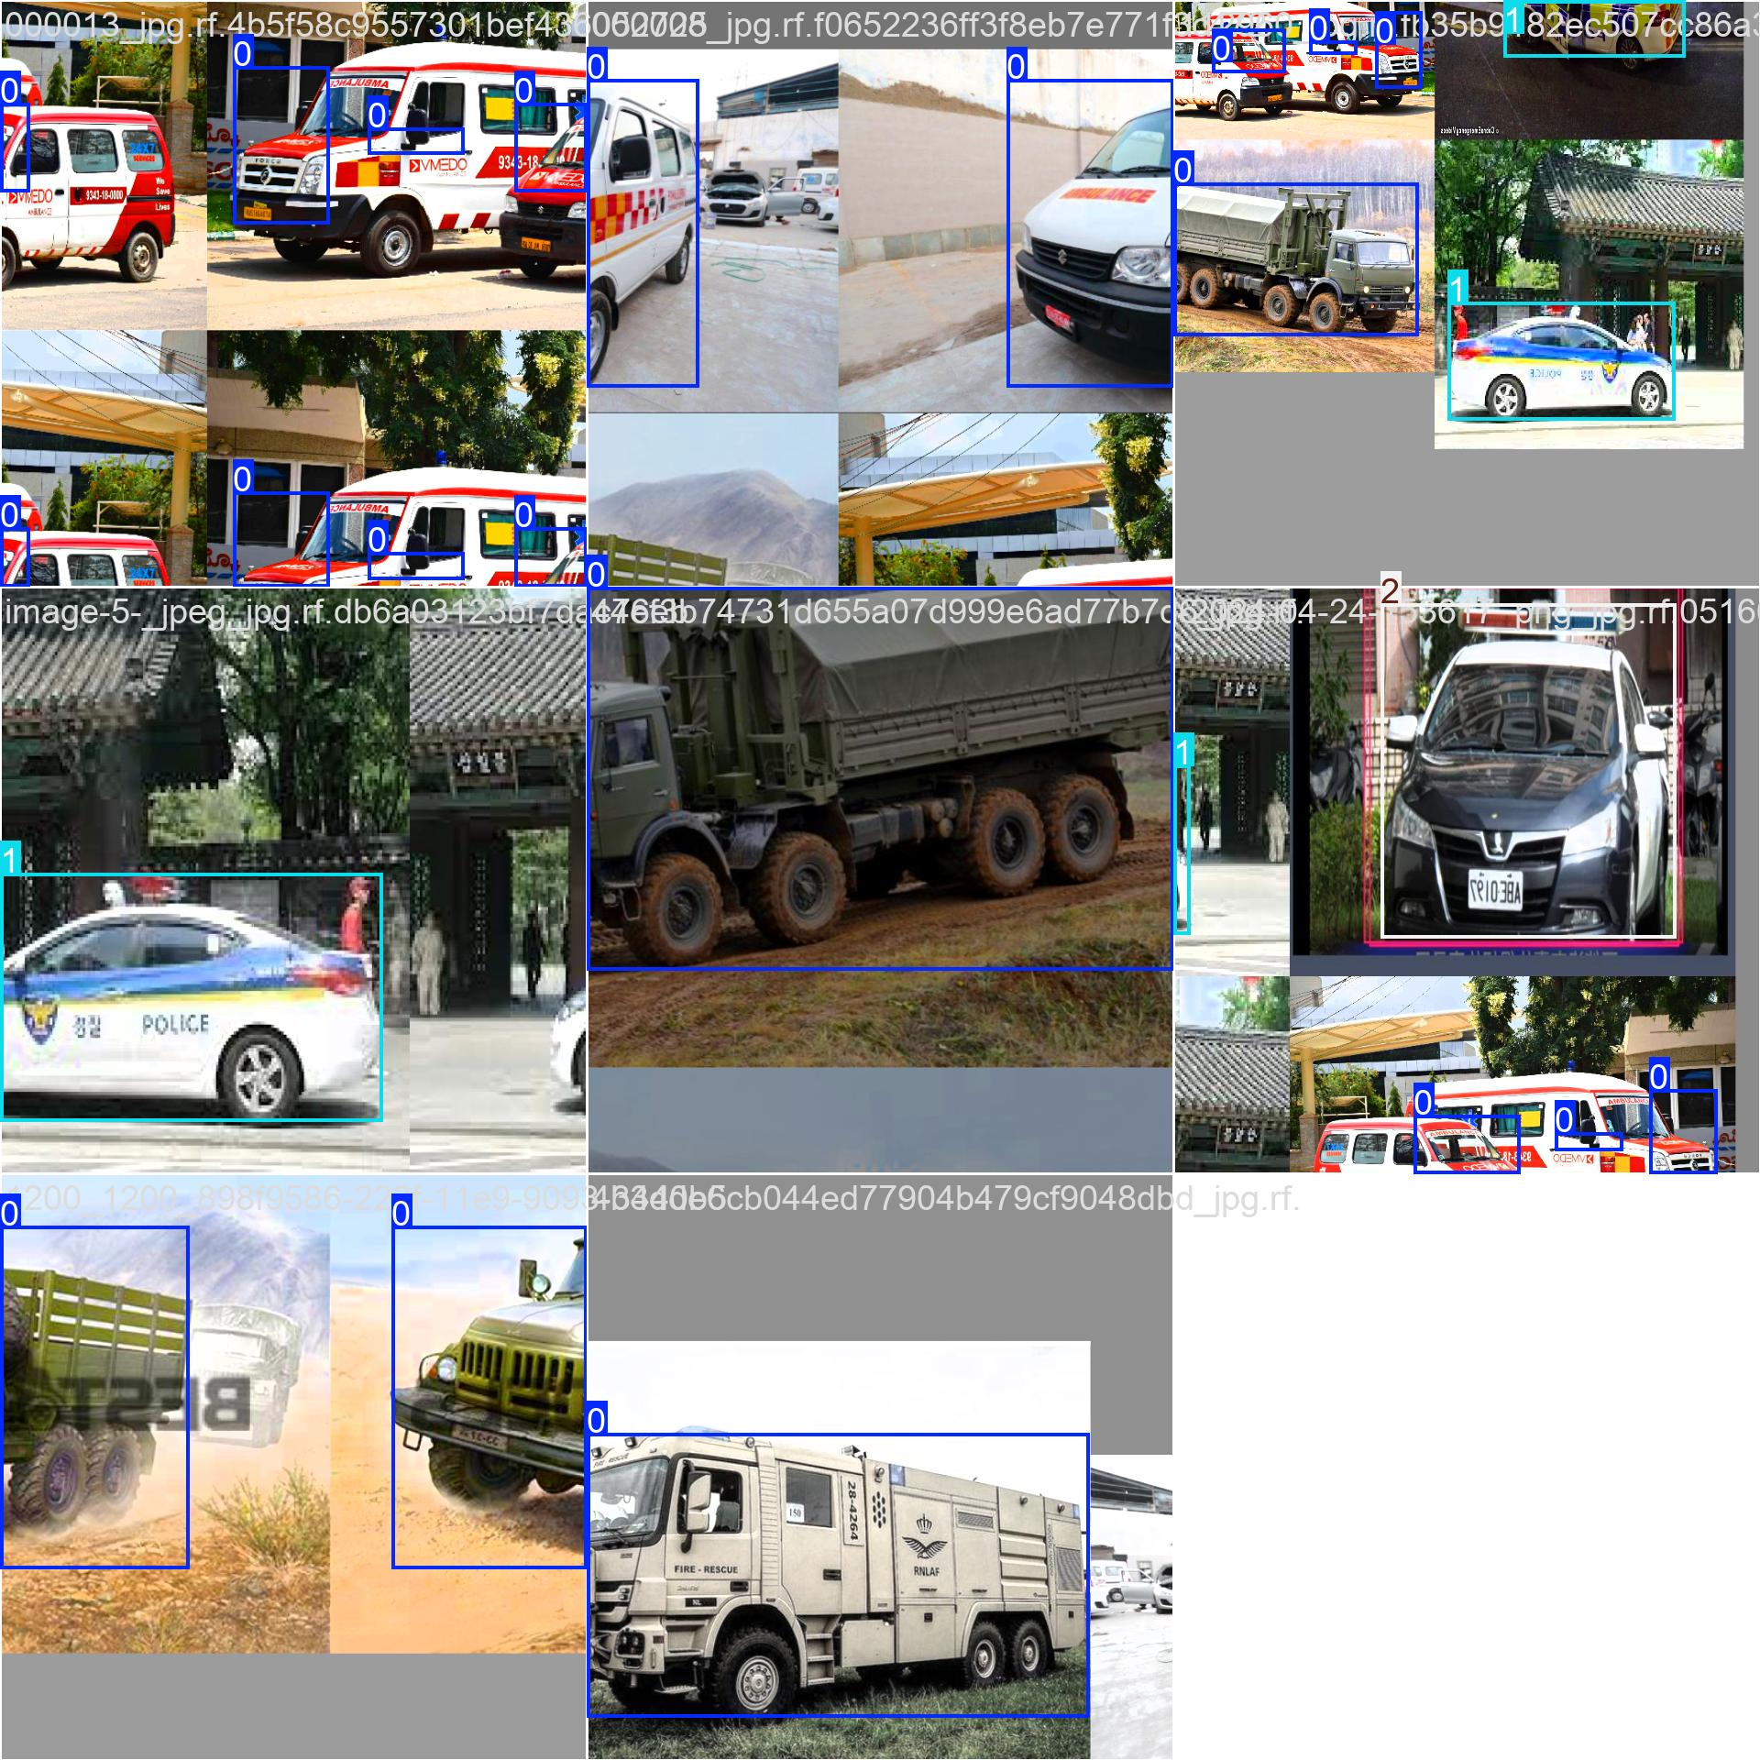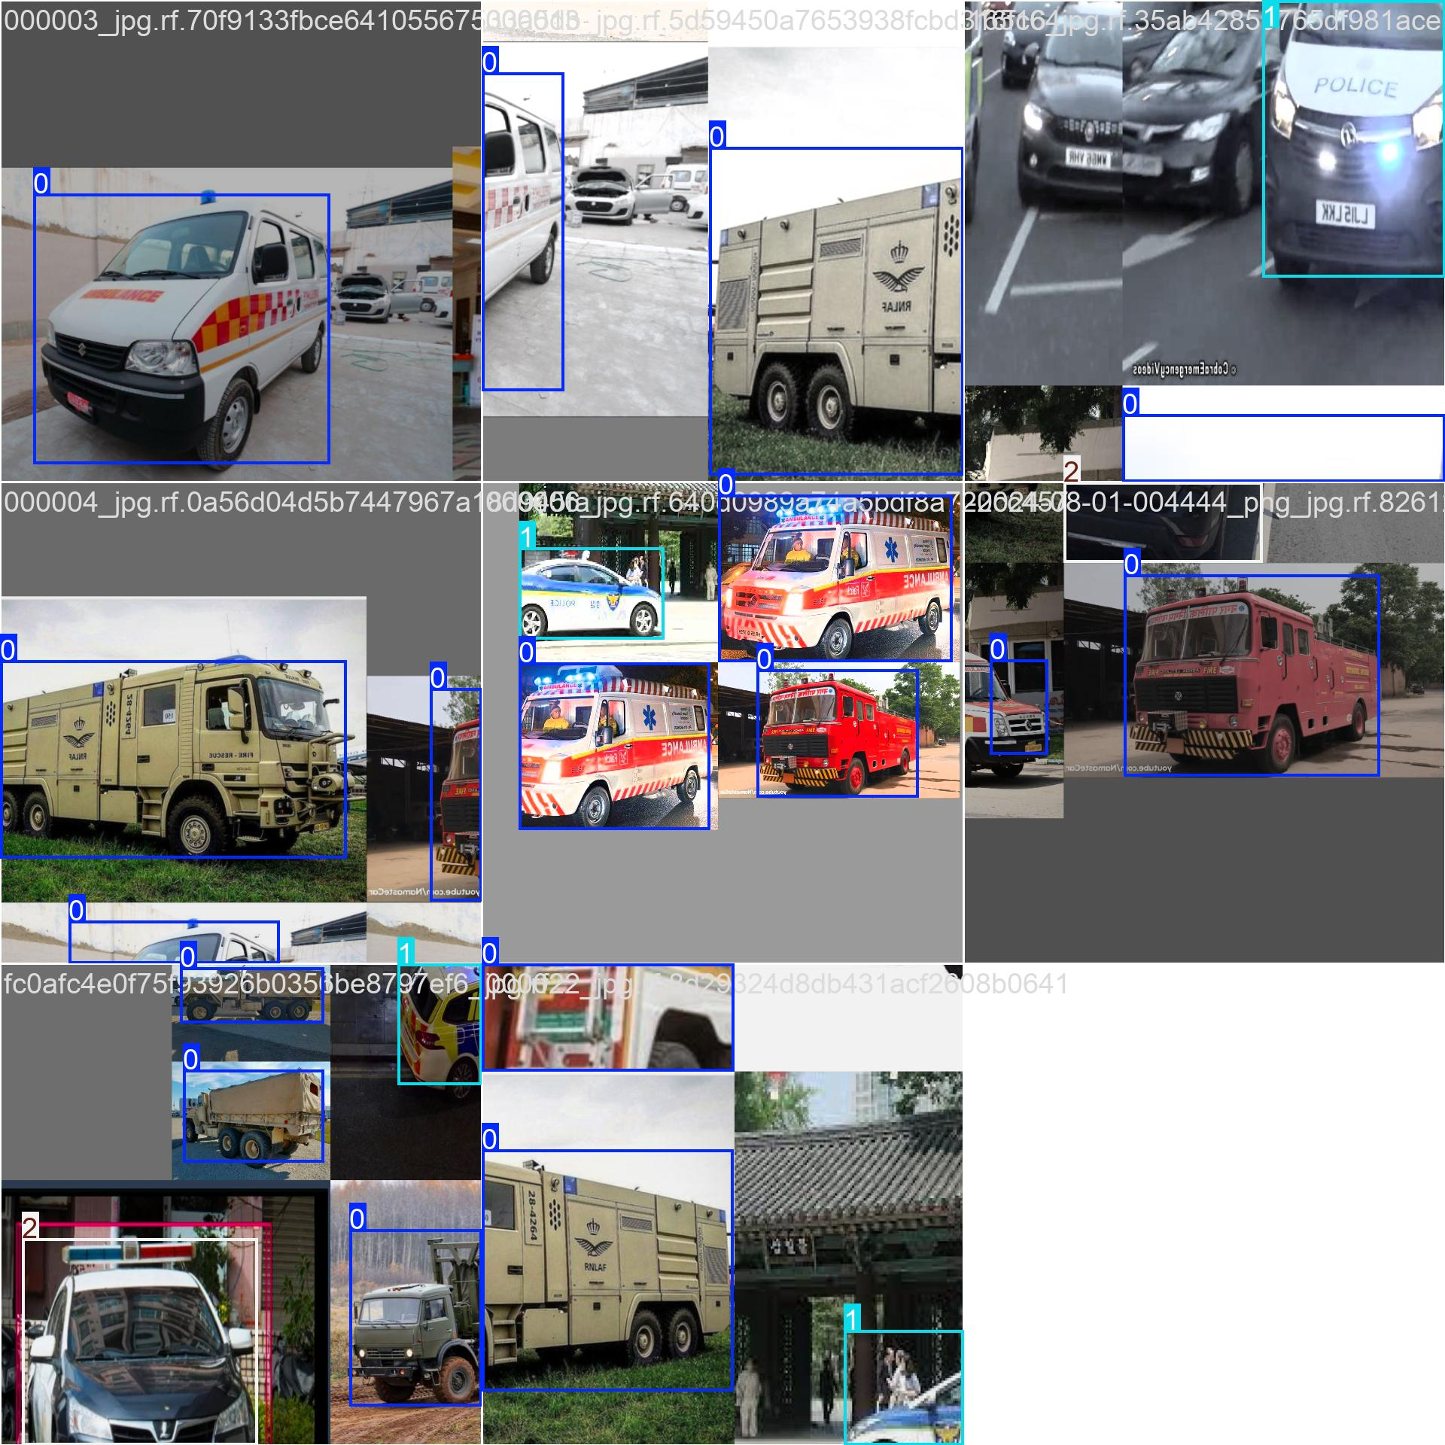
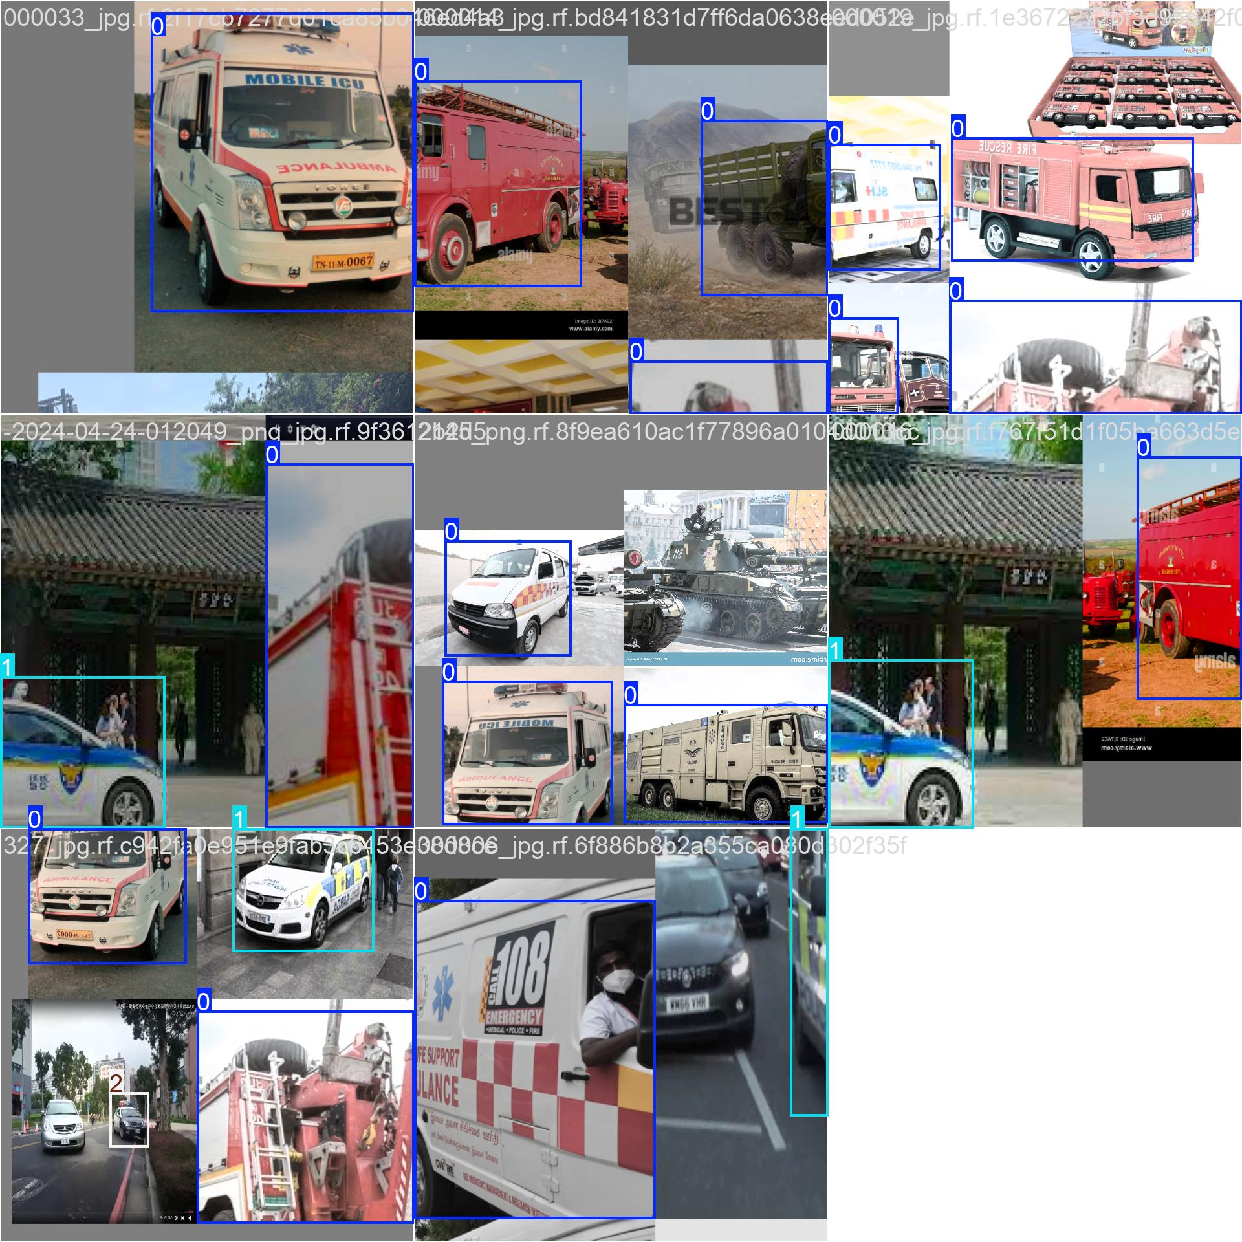

The system demonstrated efficient detection under different lighting and environmental conditions. Emergency vehicles were recognized with over 92% accuracy, while animal detection achieved 90%. The adaptive signal control logic reduced average waiting time at intersections by approximately 18% in simulated scenarios.
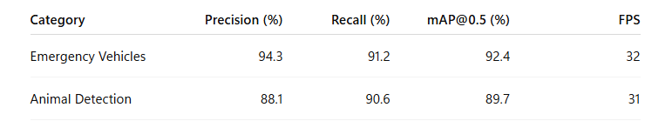

The ITMS is expected to achieve:
- Significant reduction in highway accidents involving animals.
- Faster emergency response times due to automated traffic signal clearance.
- Improved traffic flow and reduced congestion.
- Real-time accident alerts to authorities and drivers.
- A scalable, low-cost model adaptable to rural and urban road networks.
Observation: YOLOv8n achieved higher precision and recall compared to earlier models, making it suitable for real-time deployment on embedded systems.

VI. Conclusion
This research successfully demonstrates the use of YOLOv8 for developing an integrated, real-time Intelligent Traffic Management System. The proposed framework enhances traffic flow, supports emergency vehicle prioritization, and reduces accident risks. Future enhancements could involve deploying the model on edge devices like NVIDIA Jetson Nano for faster inference and integrating vehicle-to-infrastructure (V2I) communication for coordinated traffic management ,integrating accident detection using optical flow and expanding the dataset for diverse weather and lighting conditions.

References
[1] J. Redmon and A. Farhadi, “YOLOv3: An Incremental Improvement,” arXiv preprint arXiv:1804.02767, 2018.
[2] G. Jocher et al., “YOLOv8: Next-Generation Object Detection,” Ultralytics, 2023.
[3] S. Ren et al., “Faster R-CNN: Towards Real-Time Object Detection with Region Proposal Networks,” IEEE TPAMI, 2017.
[4] M. Tan and Q. Le, “EfficientDet: Scalable and Efficient Object Detection,” CVPR, 2020.
[5] S. Thakur et al., “Deep Learning Approaches for Intelligent Traffic Systems,” IEEE Access, vol. 10, pp. 54321–54330, 2022.

